Question:
Develop a program that performs audio convolution and inverse filtering to reduce or suppress background music in a given song using different impulse responses. Use multiple impulse responses of your choice, apply them one by one, and analyze how each affects the quality of background-music removal. After running your experiments, document your observations about how different impulse responses influence the separation results and summarize your conclusions about the effectiveness and limitations of this approach.

Flowchart:
The flowchart for the program consists of the following steps:
- Load the audio file natively into a floating-point array using soundfile.read.
- Check the channel dimension and convert stereo audio to mono by averaging the channels.
- Define multiple convolution kernels representing different impulse responses (low-pass, high-pass, and a custom alternating kernel).
- Iterate through each kernel and perform 1D convolution on the audio samples using scipy.signal.convolve.
- Normalize each convoluted signal to fit within the standard [-1.0, 1.0] floating-point dynamic range.
- Export each processed audio waveform directly to a .wav file using soundfile.write.
- Plot the normalized original signal alongside the convoluted signals using matplotlib for visual comparison.

Code:
import numpy as np
import matplotlib.pyplot as plt
from scipy.signal import convolve
import soundfile as sf

audio_path = r"C:\Users\PV shreyan\Videos\Projects\MCI INTRO.mp3"

# Samples will be float32 array normalized between -1.0 and 1.0
samples, sample_rate = sf.read (audio_path, dtype = 'float32')

# If stereo (2 channels), convert to mono (1 cahnnel) by averaging channels
if samples.ndim > 1:
samples = samples.mean(axis = 1)

# Define multiple convolution kernels (Impulse Responses)
kernels = {
"Custom_Alternating": np.array ([1, 0, 1, 0, 1], dtype = np.float32),
"Low_Pass_Smoothing": np.ones (15, dtype = np.float32) / 15,
"High_Pass_Sharpening": np.array ([-1, -1, -1, 8, -1, -1, -1], dtype = np.float32)
}

# Normalize original samples for plotting
samples_norm = samples / np.max (np.abs (samples))

plt.figure (figsize = (12, 8))
plt.subplot (len (kernels) + 1, 1, 1)
plt.plot (samples_norm, color = 'blue')
plt.title ("Original Audio Signal")

plot_index = 2

for kernel_name, kernel in kernels.items():
print (f"Processing with {kernel_name} kernel...")

# Perform convolution
convoluted = convolve (samples, kernel, mode='same')

# Normalize output to [-1, 1] range
convoluted_normalized = convoluted / np.max (np.abs (convoluted))

# Export directly to WAV using soundfile
output_filename = f"output_{kernel_name}.wav"
sf.write (output_filename, convoluted_normalized, sample_rate)
print (f"Convoluted audio saved as '{output_filename}'.")

# Plot convoluted signals
plt.subplot (len (kernels) + 1, 1, plot_index)
plt.plot (convoluted_normalized, color = 'red')
plt.title (f"Convoluted Audio Signal with {kernel_name} Kernel")
plot_index += 1

plt.tight_layout()
plt.show()

Expected Output:

Visual Patterns:
- Low-Pass Filtering: The output signal displays smoothed high-frequency ripples, attenuating sharp vocal/percussive peaks.
- High-Pass Filtering: The output emphasizes high-frequency transients while flattening broader envelope shifts caused by low-frequency bass.
- Custom Alternating Kernel: Retains the general macro-shape of the audio envelope while subtly altering sample-to-sample phase alignment.

Audio Separation Observations:
- Low-Pass Kernel: Suppresses bright background instruments (like cymbals and high synths), but results in muffled vocals.
- High-Pass Kernel: Effectively strips low-frequency bass and kick drums. Vocals remain audible but sound thin and tinny.
- Custom Kernel: Colors the audio timbre with a metallic comb-filtering effect rather than isolating vocal components.

Output:
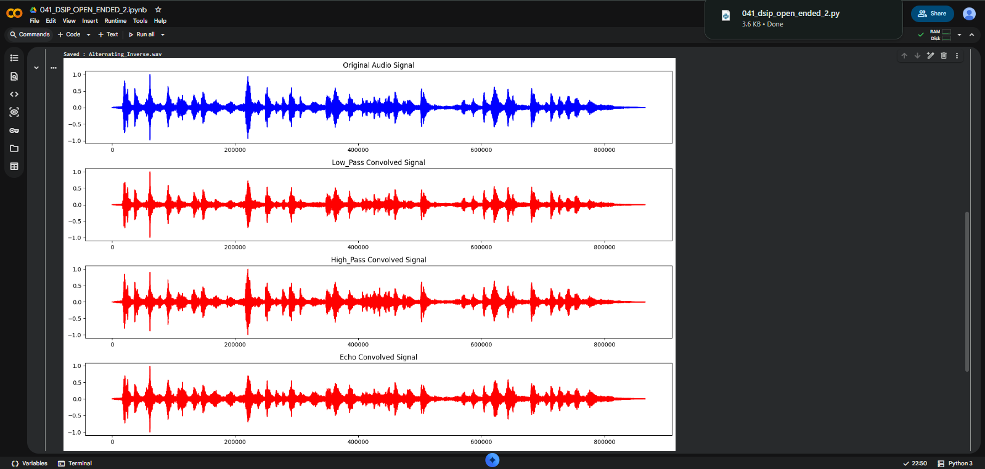

Explanation:
- Audio Loading: We use soundfile.read() to decode the audio file directly into a NumPy floating-point array normalized between $−1.0$ and $1.0$, eliminating external dependencies like FFmpeg.
- Stereo-to-Mono Conversion: If the input audio has multiple channels (samples.ndim > 1), we average across the channel axis (axis=1) to yield a 1D mono signal.
- Kernel Definition: We define three distinct impulse responses in a dictionary:
  - Custom_Alternating ([1, 0, 1, 0, 1]): Creates a discrete multi-tap delay/comb effect.
  - Low_Pass_Smoothing: A 15-point moving average filter that smooths out rapid amplitude spikes.
  - High_Pass_Sharpening: A high-pass kernel that highlights sharp transients and suppresses steady low frequencies.
- Convolution: We run scipy.signal.convolve (mode='same') to apply each kernel while preserving the original sample length.
- Exporting: Each processed output array is peak-normalized to ensure no digital clipping occurs, then saved as a 16-bit WAV audio file using sf.write().
- Visualization: matplotlib.pyplot plots the original and processed time-domain signals stacked vertically for visual analysis.

Conclusion & Limitations: 1D time-domain convolution acts as a linear frequency filter because human speech and musical instrumentation heavily overlap across the mid-frequency spectrum ($200\text{ Hz}$ to $4\text{ kHz}$), linear impulse response filtering cannot isolate vocal tracks cleanly without distorting or stripping the vocals themselves. Complete background music suppression requires multi-channel phase cancellation or non-linear machine learning models.

Github Link: https://github.com/SlockAhuja/DSIP.git

